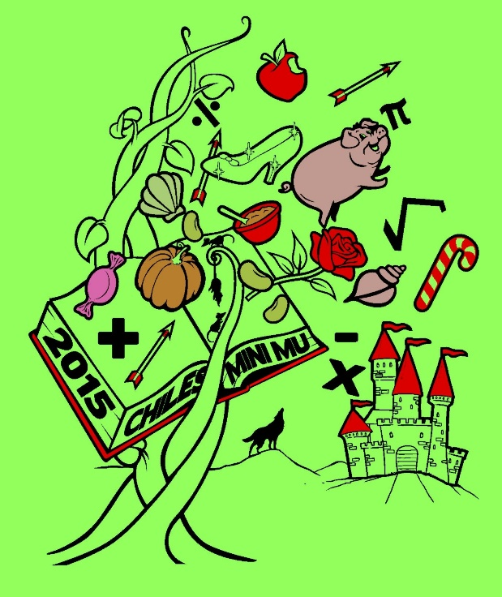

**2015**

**CHILES MINI MU**

**12 December 2015**

**Lawton Chiles High School**

**Hosted by Chiles Mu Alpha**

**Theta**

**GEOMETRY**

**SESSION 2**

**RUMPELSTILSKIN**

Once upon a time, in a land far away, there was an imp named Rumpelstiltskin. By using his imp magic, he can create miracles, such as spinning straw into gold. However, not many knew that he was also quite the mathematician. In his spare time, he wrote this test to challenge the young minds of the kingdom. This is the Rumpelstiltskin Geometry Test. You have 60 minutes to complete the following 30 multiple-choice questions. Choices A through D are answer choices for every problem. Choice E stands for “none of the above,” or NOTA. Scoring is as follows: 5 points for a correct answer, 1 point if left unanswered, and 0 points for an incorrect response. Units are assumed. Figures are not necessarily drawn to scale.Good luck!

